Recognizing visual images in your mind and seeing everything in the picture

This is one that I have used once and like the idea of but can’t quite figure out the sequence, etc. to make it work best. I would like it to have two purposes: 1) to have students recognize the visual images in their mind and how those visual images in the mind might “color” how they see and read history, and 2) to have students work on seeing everything in the picture.

Basically, I want the students to describe the visual image in their mind for a 1930s photograph with the caption “Children of Negro family on relief playing – Chicago”
(The one time I did this everyone in the class had a visual image of children playing in the street.)

The photograph I show them and ask them to describe, i.e. to try to see everything in is this. After they have written a description of it and we have compared and discussed descriptions, I ask them to write a story for it and we discuss and compare their stories.

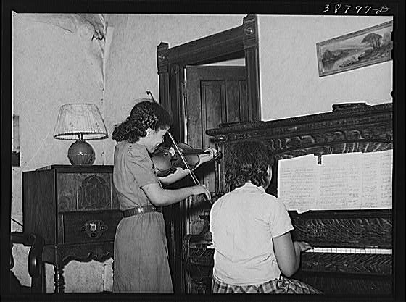

Then after that I show them the title the photographer gave to the picture, “Children of Negro family on relief playing” and we talk about how this differs from the visual image in their heads and why they have the one they do and how that might shape their reading of written history texts and documents.

The sequencing problem I have is that if I have them do the visual image in their mind and then have them do the photograph, some students get it and write about the photograph differently and if I have them do the photograph first and then ask them about the visual image in their mind that goes with the title, that also shapes what they would say.

In any case, I’m including it here in our collection of sample assignments as an example of some of what I want to do images in my history courses.

